Fill in the following tables:

|  |  |  |  |  |  |  |  |  |  |  |  |  |  |  |
| --- | --- | --- | --- | --- | --- | --- | --- | --- | --- | --- | --- | --- | --- | --- |
| Number | 2 | 3 | 4 | 5 | 6 | 7 | 8 | 9 | 10 | 11 | 12 | 13 | 14 | 15 |
| Perfect  Square |  |  |  |  |  |  |  |  |  |  |  |  |  |  |

|  |  |  |  |  |  |  |  |  |  |  |  |  |  |
| --- | --- | --- | --- | --- | --- | --- | --- | --- | --- | --- | --- | --- | --- |
| Number | 2 | 3 | 4 | 5 | 6 | 7 | 8 | 9 | 10 | Number | 2 | 3 | 4 |
| Perfect Cube |  |  |  |  |  |  |  |  |  | Perfect Fourth |  |  |  |

What is a radical???

$$\sqrt[2]{25}$$

Example 1: Evaluate each radical.

|  |  |  |  |
| --- | --- | --- | --- |
| a) | b) | c) | d) |

**Investigate:**

1. Find two consecutive perfect squares that are closest to 40. _________ and _________
2. Use your result from “a” to estimate to one decimal place. Revise your estimate if needed. No calculators allowed.
3. Find two consecutive perfect cubes that are closest to 60. __________ and __________
4. Use your result from “c” to estimate to one decimal place. Revise your estimate if needed. No calculators allowed.



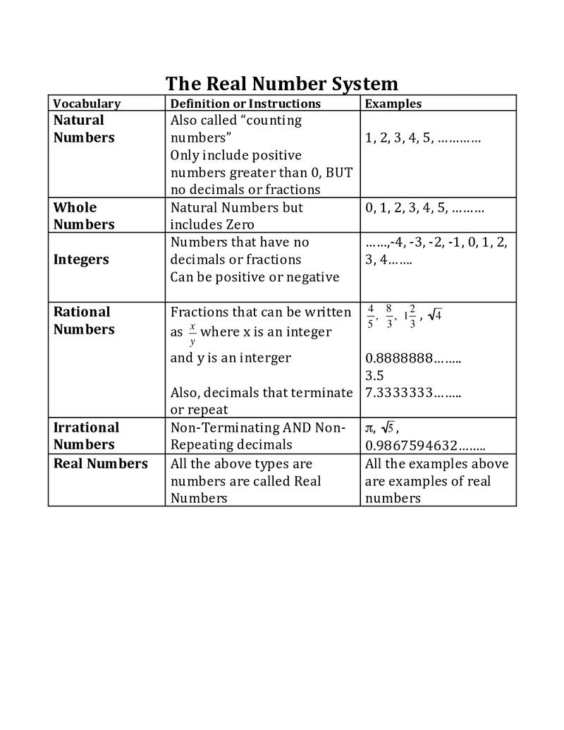

Radicals that are square roots of perfect squares, cube roots of perfect cubes, etc.. are called _______________ numbers. (e.g. from last page  = ___________; _____________; _____= ___________) .   
Rational numbers have decimal representations that either ___________________ or ___________________.



What about square roots that are NOT perfect squares, or cube roots that are NOT perfect cubes, etc….

(e.g. from last page = _____________; = ________________). They are called ________________ numbers. Irrational numbers have decimal representations that do not __________________ nor repeat!

Example 2: Determine if each number is rational or irrational and explain how you know.

a)  b) 

e)  f) 0.123123412345123456…

Example 3: Order these numbers from greatest to least on the number line. (You’ll have to draw your own line)

,,,,

**Home Practice:**

**MUST DO:** Page 206: 3 & P. 211: 5, 9, 12 (Please try these questions without a calculator)