**Electric current (I)**

What is electric current?

**How is current measured?**

* Measured in _______________________
* 1 ampere (Amp, A) = 1_______________ per _______________________
  + (I = Q/t) I =
  + Q = t =
* Measured using an ______________________________
* Ammeters must be connected in __________________________, so that the ammeter is in the path of the current and the current goes through the ammeter.
* The current we measure is often much smaller than 1A, so we often use milliamps (_______). 1mA = 0.001A OR ____________mA = 1A

Example #1:

If 120C goes past a point in 1 minute, what is the current?

Example #2:

A current of 200mA is flowing for 30 seconds. How much charge goes past a point in that time?

**Current in a series circuit**

Current is __________________________ at all points in a series circuit

**Current in a parallel circuit**

Current ________________________ when there is a branch point in a circuit.

**Current practice problems**

1. What is the current if it takes 48 seconds for 24 coulombs of charge to flow through a lamp?
2. How long would it take for 100C of current to pass through a small bulb if the current was 50mA?
3. 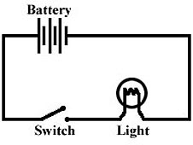If the current measured at point A in the circuit below was 120mA, what would the current be if measured at point B? Explain your answer.



1. How much charge would pass through a kettle if the current was 1.5A and the kettle was running for 5 minutes?
2. Find the missing current for each of the circuits shown.

