Germ Theory of Disease Name________________________________
Answer the following questions while watching the video about the origins of germ theory
- What is miasma theory?

- How did the invention of microscopes change the way scientists thought about illness?

- Who was John Snow? What disease interested him, and how did he think it was spread?

- What effect did shutting off the Broad Street water pump have on the cholera outbreak?

- What contribution did Robert Koch make to germ theory?

- What is Louis Pasteur’s role in the development of germ theory?

With a partner, find answers to the following:
- What do antibiotics do?

- What are antibiotic resistant bacteria? Why are they a problem?

- What is an epidemic? What is a pandemic?

- How does a vaccine help protect you?
Pathogens = microorganisms that cause disease/illness

Type of pathogen | Diagram | Examples of diseases | Treatment
Bacteria | 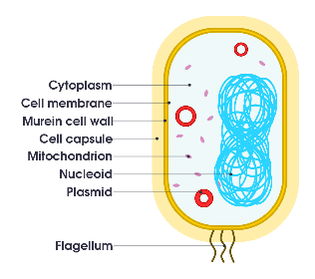
Virus | 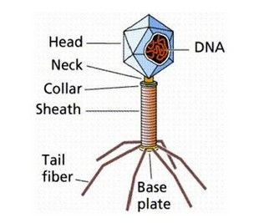  This Photo by Unknown Author is licensed under CC BY-ND
Fungus
parasite | 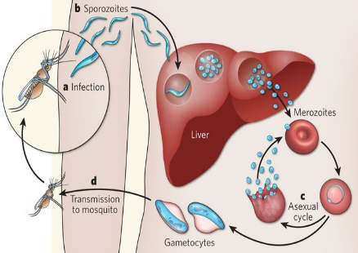  This Photo by Unknown Author is licensed under CC BY-SA-NC

