The Immune System and Your Body’s Defenses
Your body’s immune system/defense against diseases consists of both specific and non-specific responses.
Non-Specific (First line physical defenses)
Skin/Mucous membrane/Cilia -

Non-specific cellular responses (once the pathogen is inside the body)
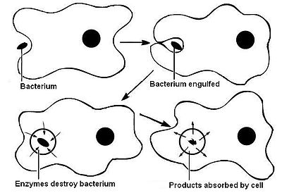
Inflammatory response –
This Photo by Unknown Author is licensed under CC BY-SA

Pathogen specific response
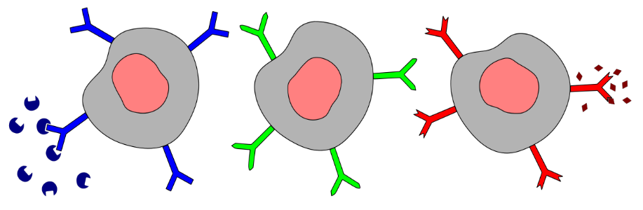
Production of antibodies -
This Photo by Unknown Author is licensed under CC BY-SA

