Slope – what is it? How do we find it? Why should I care?
What is slope?
- A way of describing how steep a line or surface is
- When referring to a graph, the slope also gives us information about which direction the line tilts (up to the right or down to the right).
How can we describe slope?

Slope is calculated by finding rise/run (change in range/change in domain)(Δy/Δx)
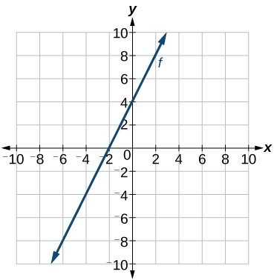
This Photo by Unknown Author is licensed under CC BY

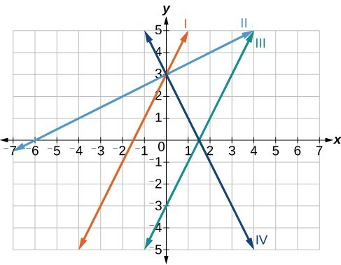
This Photo by Unknown Author is licensed under CC BY

_____________________________________________________________________________________
We can also find the slope using the coordinates of two points. $$slope= \frac{(y2-y1)}{(x2-x1)}$$
Find the slope of a line that passes through (1, 2) and (2, 4)

Find the slope of a line that passes through (0,12) and (3, 3)

A line with a slope of ¾ passes through (1,4) and (5, z). Find the value of z. Explain your thinking.

